Your Guide to Student Discounts

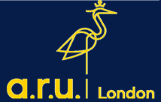

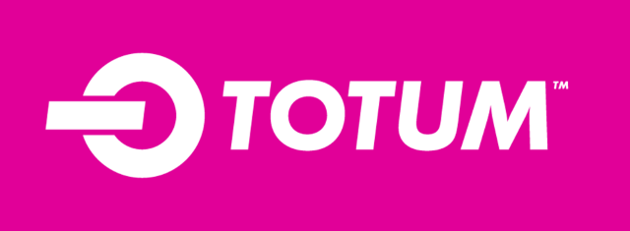

TOTUM is the #1 student discount card and app giving you access to huge offers on food and essentials, tech, travel and home delivery. Plus, fashion, beauty and a whole lot more. Visit https://www.totum.com/ for more information.
For detailed guide on how to apply please see our TOTUM Card Guide.
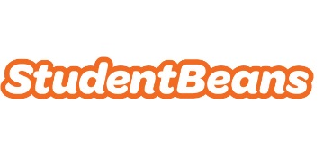

Sing up to access student discount codes from your favourite brands including Apple, ASOS, Domino’s, Superdrug and more. Download the app to get instant access to all the latest student discounts wherever you are.
Visit https://www.studentbeans.com/uk for more information.
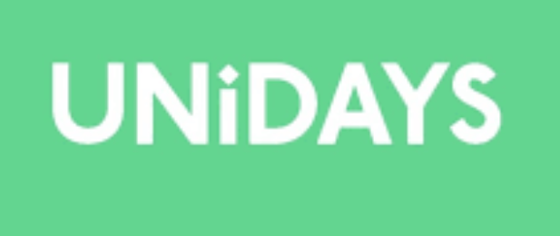

UNiDAYS gives you discounts to shops, restaurants and many more! With UNiDAYS you can collect rewards and receive a voucher to spend on one of the preferred brands.
Visit https://www.myunidays.com/GB/en-GB for more information.
For detailed guide on how to apply please see our UNiDAYS Guide.

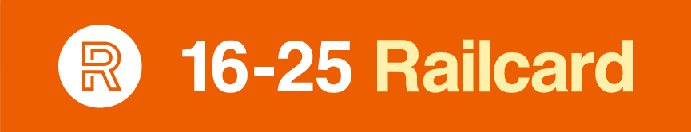

Get 1/3 off train travel with a 16-25 Railcard. Average annual savings of up to £189. Just £30 for 1 year or £70 for 3 years. For everyone aged 16-25 and mature students. Visit https://www.16-25railcard.co.uk/ for more information.
For detailed guide on how to apply please see our Railcard Application Guide.

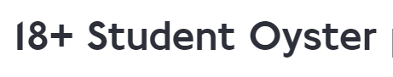

If you're 18 or over, a student and living in a London borough, you can get discounted travel with an Oyster photocard. Save 30% on adult-rate Travelcards and Bus & Tram Pass season tickets. Visit https://tfl.gov.uk/ for more information.
For detailed guide on how to apply please see our Oyster Card Application Guide.

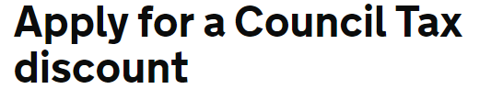

Households where everyone’s a full-time student do not have to pay Council Tax. If you do get a bill, you can apply for an exemption. To count as a full-time student, your course must:
- last at least 1 year
- involve at least 21 hours study per week.
Visit https://www.gov.uk/ for more information.

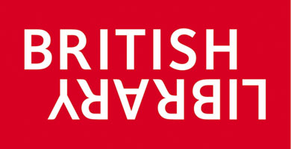

Our students have access to other Universities Libraries through SCONUL scheme. Visit https://www.sconul.ac.uk/ for more information and apply. In addition to this you can apply for Readers Pass at British Library.

Start your 6-month trial. Then, enjoy Prime at half the price. 6-month trial courtesy of Microsoft Surface, for new members only. After your trial, Prime Student is just £3.99/month. Cancel anytime.
Visit https://www.amazon.co.uk/ for more information and apply.

Students get Spotify Premium free for 1 month. Only £5.99/month after. Cancel anytime. Visit https://www.spotify.com/uk/ for more information and apply,
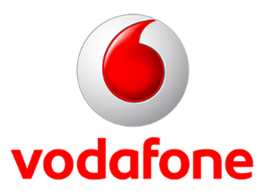

Students can get 20% EE student discount and 500MB free data, every month. Visit https://ee.co.uk/ for more information.

Vodafone offers 10% discount on selected airtime plans, pay monthly tablets and SIM only plans for students. Visit https://www.vodafone.co.uk/ for more information.
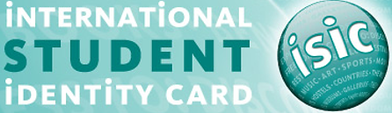

Save money both home and abroad with the ISIC -The International Student Discount Card which gives you access to exclusive fares and travel deals with STA Travel to discounts on transport within the UK, accommodation throughout Europe, dining & takeaway and many more. Visit https://www.myisic.co.uk/ for more information.
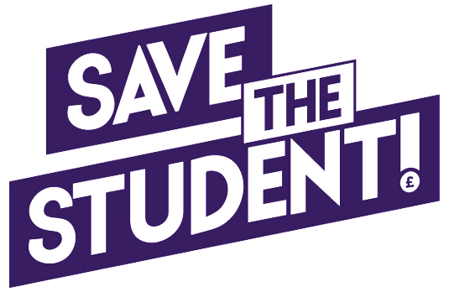

Visit Save the Students at https://www.savethestudent.org/ to find hundreds of discounts across the UK by searching for brands/product by category.

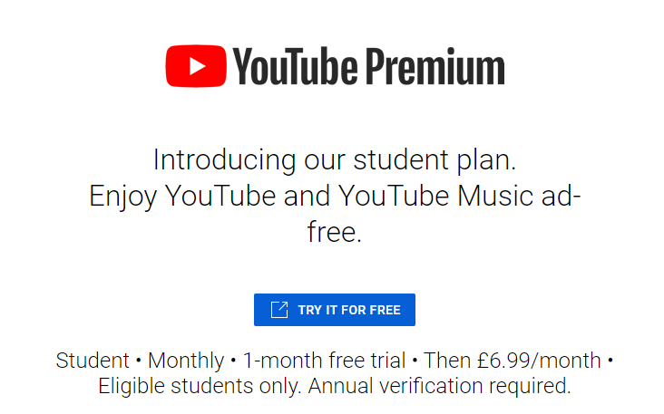

Students can enjoy 1 month’s free trial of YouTube Premium for a reduced cost of £6.99 per month. This includes ad-free videos and downloading videos to watch offline. Your package will also include YouTube Premium Music which you will be able to download music content from a selection of millions of tracks.
Visit https://www.youtube.com/musicpremium/student for further information

You can find detailed guides on how to apply for certain discounts under My Support Page on your VLE. They are also available on ARU London Website https://london.aru.ac.uk/student-life/student-support-tools/guides

